Parent/Carer Report Guide
Your child will receive two progress reports this year, one in November and a second in May. We are trialling a new format for reporting which we hope you will find to be clearer and more useful. Below is an explanation of the terminology and vocabulary we have used in these new reports to help you understand the progress your child is making.
Curricular Areas

- Expressive Arts
- Health and Wellbeing
- Languages
- Mathematics
- Religious and Moral Education
- Sciences
- Social Studies
- Technologies

Literacy, Numeracy and Health and Wellbeing are given added importance because these skills are vital in everyday life. Skills in these subjects are covered across all areas of the curriculum.
Several of these curricular areas may not be taught discreetly and instead be covered together through interdisciplinary learning, which we would often refer to as a topic. Each class usually chooses one or two board topics each term, such as transport, which will includes a range of curricular areas.
In our first report in November some curricular areas or subjects may be noted as ‘Not yet covered’ in your child’s report. This simply means that these areas are planned to be covered later in the year. Progress in their area will be noted in the second report in May.
Curriculum Levels
These are shown in our reports under the title ‘Working within’. The diagram below shows the expected stage at which most children will be working through each level. However, your child may be working at a different level to their stage in order to better support their learning needs and abilities. This could also be different for each curricular area as each child has a wide range of abilities and strengths.
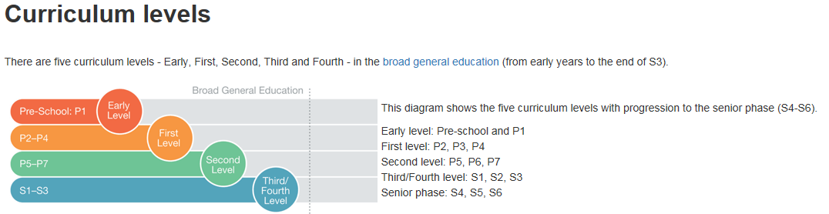
Progress
In this section of the report your child’s teacher will note the progress their making through the curriculum level. They will choose one of the following statements;
On track – Your child is making the expected progress through this curriculum level.
Ahead of track – Your child is progressing beyond their expected curriculum level and will be challenged to extend their learning further.

Not yet on track – Your child has not yet made the expected progress in their curriculum level and but being supported to do so.
Please note that while your child may not yet be making expected progress for their level this is not an indicator of their effort which is noted separately in the report.
Effort
Your child’s teacher will also select a statement describing your child’s effort in each curricular area. No matter your child’s level or progress this will be based on their attitude and work ethic. The teachers will choose from the following options;
- Excellent
- Very good
- Good
- Satisfactory
- Needs improvement
Teacher Comments
Here you find comments on how your child gets on in school in general, for example behaviour, attitude, social skills etc. Also noted here will be any particularly strengths your child displays and any notable areas of improvement.
A comment will also be included from our head teacher or depute.
Parent/ Carer Comments
We would like you to share this report with your child and discuss their progress and effort in school. Please add your own comment on your child’s progress and return to school. Your feedback is always very important to us.
We would also appreciate your feedback on our new reporting style. Scan the QR code at the bottom of the report to access our questionnaire, or follow the link below.
https://forms.office.com/Pages/ResponsePage.aspx?id=oyzTzM4Wj0KVQTctawUZKSZpoOMmt9pJsjZHXOxgJtFUMTZRQ0pUMDlSRTFCMUY5MlM1OVBYMEhYQi4u
Progress for children with English as an additional language
Children learning English will be at the following stages of English language development:
- New to English
- Early Acquisition
- Developing Competence
Their skills across talking, listening, reading and writing will continue to develop as they acquire English. Children may not be at the expected levels of language and literacy for their stage until their English language has more fully developed.
Please note this guide is also available in Arabic on our school website.
هذا الدليل متوفر ومتاح بالعربية على موقع المدرسة الإلكتروني

