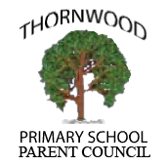

Agenda
Parent Council Meeting – March 6th at 7pm

- School uniform
- Maths homework
- Spring Disco
- Summer Fair
- A.O.B
Next meeting date 8th May 2017 at 7pm.

